**NURSERY READING LESSON NOTES TERM 3 2022**.

**Wk**. 1

**PD**. I

**Content**; Revision of the five trays of Jolly phonics

S, a. t. I, p, n ck, e, h, r, m, d, g, o, u

L, f, b, ai,j, oa, ie, ee, z, w, ng, v, oo, oo

**Activities**; -Reading the sounds

-Relating sounds to pictures.

-t p oa ie oo m

PD;2

Content;

-Revision of the five trays of Jolly phonics

-Reading the sounds.

-Identifying pictures for the given sounds oral

ee 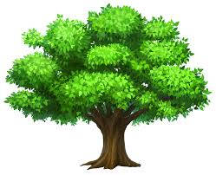 ai 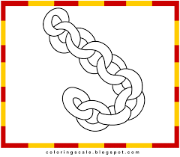 s 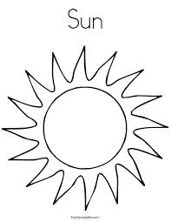

Drawing pictures for the given sounds( in the books)

r ---- -----, ee ---,------,oa ---, ------

-Reading the sounds.

-Naming pictures.

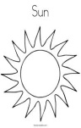 -----------

-------------

 ---------- ------------ A picture of king

Wk 1

Pd 4

Content:

Introducing sound y and x

Activities:

* Reading all the sounds of the 5 trays.
* Relating sounds to pictures.

b 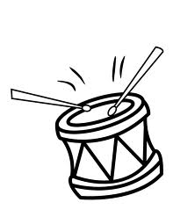d  oo

Naming pictures. (Paper work)

--------- 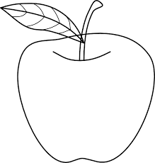---------

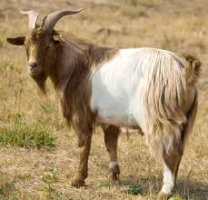 ----------- -------- 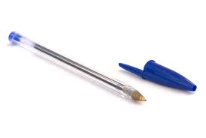--------

Content:

- Introducing sound y and x

-Telling all the storyline about children eating a yellow yogurt with their

Sandwiches

* Doing action of y.
* Sorting sound y.

b, d y

c e m

y I h

Sorting sound y from the cards

- Writing sound y

* Reading words with y

Yam, yogurt, yatch, yellow

WK.2

PD 2

Activities;

* Making sentences using words of y.

-It is a York. images (5)

- It is a yam. 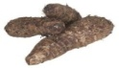

-It is a yatch.

-It is a yogurt. 

Pd 3

Pd 1

Activities:

Content:

Introducing sound x

* Telling the storyline of x about a boy who had an x-ray, xylophone ,fox, box, axe
* Write sound x.
* Reading simple sentences with words of x

- This is a box, 

-This is a chair 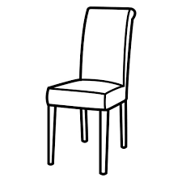

-This is a fox . 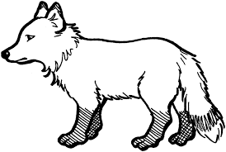

-This is an axe.

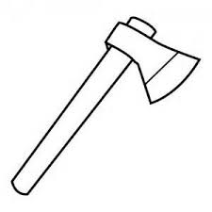

* Wk3
* Pd 1
* Content:
* Introducing sound ch:

-ACTIVITIES:

-Telling the storyline for sound ch. about children having a ride in an old stream train.

-Doing the action of ch.

-Reading words of ch.

Chair, chain, chick, chips.

Drawing pictures for the words chair, -------- chain ------ chick------

-Writing sound ch.

-Making sentences using words of ch.

It is a chair.

 It is a chain.

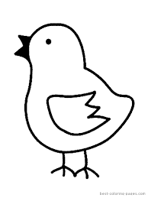It is a chick

Telling the the storyline and reciting the rhyme of sound sh.

-Doing the action of sh, shell, sheep, fish, shop.

WK3

PD3 and 4

ACTIVITIES :

-Drawing pictures for the words,

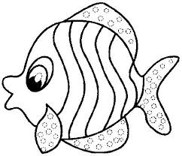fish 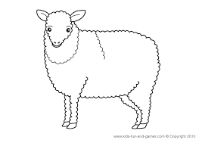sheep.

Writing sound sh

Matching picture to words of ch and sh

Chair 

Shirt 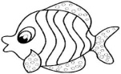

Chain 

Fish 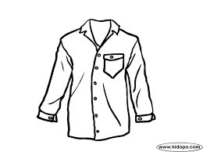

WK4

PD 1

CONTENT:

Introducing sound th Th

Telling the storyline of th, Th about the naughty clown.

-Reciting the rhyme of th

- Doing the action of th.

- Reading words of th – thin, three, cloth, then, that, this, with.

- Matching pictures with the learnt words.

Sheep 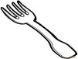

Snail 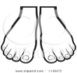

feet 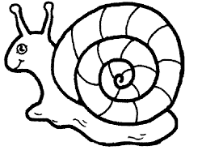

boat 

fork 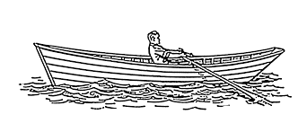

WK 3

PD 3and 4

Content:

ACTIVITIES:

Fill in the missing letter sounds of ch, th and sh

fi _ 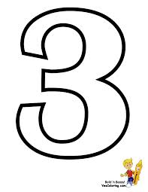_ree

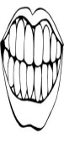tee_ __ip

__ick 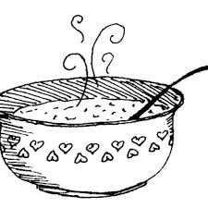di_

chur_

WK 5

PD 1

CONTENT:

Blending sounds form words,

Ch- ai- n. sh-i-p

Ch-i-ck, s-i-ck

f-oo-d, m-oo-n,dr-e-ss

h-o-t

ACTIVITIES

(ORAL ACTIVITY)

Blending sounds ch-ai-n, sh-i-p, ch-i-ck,

bl-a-ck, t-e-nt, f-oo-d, m-oo-n, dr-e-ss

h- o-t ,m-u-st,j-u-st,

WK5

PD2

Activities:

Naming pictures

--------- ---------

--------- 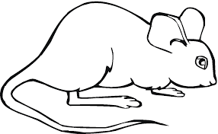 ---------- --------

PD 3

Listen and write.

Fish, chick, mat, pot, van, tin, tree, flag, tent.

Pd

4

Read and draw.

It is a cat . ---------

It is a fish, --------

It is a fan. -------

It is a van. -------

It is a chick, -------- (paper work)

- Telling the story line of qu about a boy who went to the park to feed the ducks.

- Reciting the rhyme of qu writing sound “ qu”

Wk 6

PD 1

CONTENT:

Introducing sound “q”

ACTIVITIES:

Reading words of qu: quil, quiet, quack, quick, que, queez,quit, quiver

,quest.

Write sound q

PD3

CONTENT:

Introducing sound ou

ACTIVITIES:

-Telling the storyline of” ou”

About a little girl who accidentally pricked her thumb.

* Doing the action.
* Reciting the rhyme
* Reading words of ou-
* Out, sour, cloud, house, pour, ouch.
* Write sound ou , house and draw.

Ou

Ou house ou cloud ou mouse

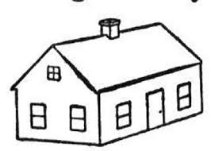  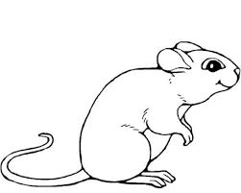( in books)

PD 4

CONTENT

ACTIVITIES:

Name these pictures. (Paper work)

|  |  |
| --- | --- |
| fish--------- | images (11)-------------- |
| \\server03\Nursery schemes and lesson notes-2014\pictures\download (10).png------------- | \\server03\Nursery schemes and lesson notes-2014\pictures\images.jpg------------ |
| download (1)--------------- | -download--------- |

Wk 7

Pd 1

Content:

Introducing sound oi

Telling the storyline of oi about the sailors calling for help.

-Doing the actions.

- Identifying words of oi

Oil, coin, boil, point, foil,

-Writing sound oi and copying words

Oil, coin, soil, voice, toilet, join.

Wk 7

Pd 2

Activities:

Read and draw pictures for the phrases. (Paper work)

1. a house and a hut -----, ---------
2. a king and a queen -----, -------
3. a coin and a man.----, -------
4. a tin and a tree----, -------
5. a ring and a rat .------,-------

6. a cat and a rat.-------,-------

Wk 7

Pd3

Content:

Introducing” ue “

Telling the storyline of sound ue about the guest pointing and saying, I think it is ue.

Doing the action.

Blending and reading words of ue

Que, value, rescue, blue, statue.

PD

4

Activities

Revision of all the learnt sounds and blending to read words.

c-a-t ,cl-ou-d ,ch-ai-n ,f-ee-t, k-i-ng,qu-ee-n,b-oa-t, c-oi-n,s-ou-nd,(orally)

Wk 8

Pd1

Content

Introducing sound er

Telling the storyline of er about the sound of a mixer .

-Doing the action.

- Blending and reading words of er , her ,sister ,dinner ,,herb, mixer, brother ,silver, better, number, river, never ,never, butter.

Pd 2

Activities

Match words to pictures

Cup 

Tent 

Mat 

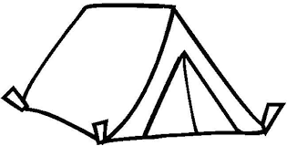

Book

coin 

Cloud 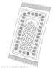

Sheep 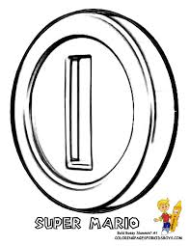

Pd 3

Content

Introducing sound ar

Activities :

Telling the story line of ar about a girl who had

a sore throat .

-Doing the action the action .

-Blending and reading words of ar, art ,park, star, car, farm, far, bar.

Pd 4

Content

Listen and write the learnt sounds.

Activities;

Listen and write

ai, ie. oa,ng ,er, ar ,ch,sh, th, oo, ee. j,g, oi, ue, or, ue, or ,ou .

Wk 9

Pd 1

Content:

Revision of all the learnt words and sounds ou, ie, ai, oo, ch, th, sh, oi, ou.

Blending and reading food, feet, stool, soil, coin, stool,dress, shirt, horn, blue, green, yellow ,shorts ,apple ,red (oral)

Pd :2

* Content :

Making sentences for the given pictures .

Activities

Make sentences using “Here ‘’

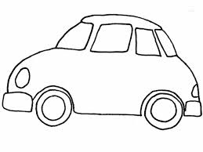 Here is a car.

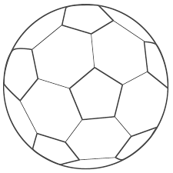

Here is a ball.

Here is a chair.

The ball is on the chair.

 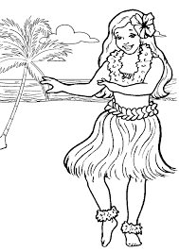She has a book. (In books)

Pd3

Activities:

Make sentences for the pictures using It is a ----------.

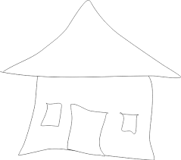-----------------------------

--------------------------------

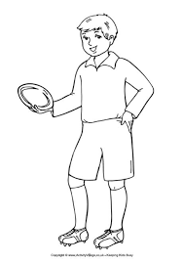------------------------------------------------

--------------------------------------------

Wk 9

Pd 4

Content:

Activities:

Read these sentences.

I am a big girl.

Jane has a red bag.

I can see the sun.

Peter is a good boy.

This is a family.

She is very fat.

He is very short.

Read and draw.

I can see a cat. ----------

I can see a spoon. ----------

I can see a ball. --------------

I can see a coin ----------

I can see a train. ----------

Wk 10

Pd 1

Content

Revision.

Activities

Pd 2

Activities

Listen and write simple words.

Boy, flag, green, tap, dish, book, axe, chair, fish, shop, thin

Pd3

Content

Revision of learnt sounds and words formed from the seven trays.

Pd4

Read, match to picture and a copy the word.

*Hen* 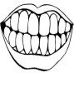---------

Book 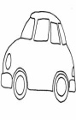-----------

Chair 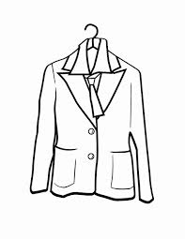----------

Teeth 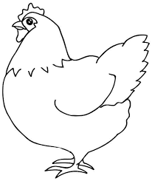--------

Car ------------

Coat  -----------

Pd 4

Complete the sentences with pictures.

* Tom has a .
* A  has two legs.
* The  is on the road.